CAFT Reconciliation Process

The purpose of this Reconciliation is to show all outstanding items that make up the total in IA (Internal Account) CAD1723300011001
Location of Master Balance Program: N: MISCommon/CAP/DATABASES/Master Balancing/Master Balancing
Location of CAFT Excel reconciliation: G: CASH MANAGEMENT SUPPORT/CAFT/IA 17233 Reconciliation/Master CAFT Rec
To retrieve balance in IA 17233 BEFORE 8:30 A.M.
- Sign into T24
- Choose ‘Enquiry- Acct & Stmt Entries
- Choose tab called Stmt Entries-Internal Acct Consolid.
- In the Account (equals) insert CAD17233
- In the Processing Date (equals) insert today’s date & go to last page
- Print this page (Print Locally)
To retrieve balance in IA 10286:
- Sign into T24
- Choose ‘Enquiry- Acct & Stmt Entries
- Choose tab called Stmt Entries-Internal Acct Consolid
- In the Account (equals) insert CAD10286
- In the Processing Date (equals) insert today’s date & go to last page
- Print this page (Print Locally)
- Balance should be $0.00. If not, do not print until after CAFT settlement is posted.
Verification that CWB Transaction Report has been downloaded with correct data:

- Open the Master Balancing program
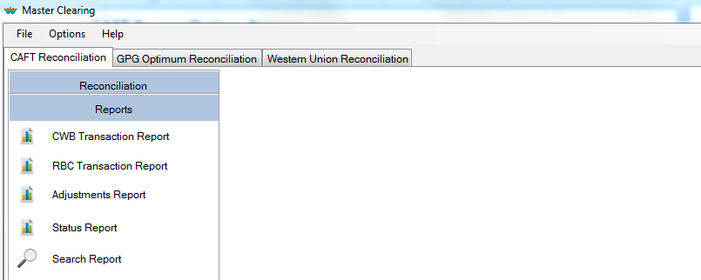
- Click on Reports tab
- Choose CWB Transaction Report and ensure the dates at the top (‘Report Date From’ & ‘Report Date To’) are one business day back
- On Mondays input date range from previous Friday to present day
- Ensure you see a number beside ‘Row Count’
- At the top right, click ‘View Report’
- Click on arrow to go to next page
- Verify the ‘Effective Date’ in the report is the day that is being balanced
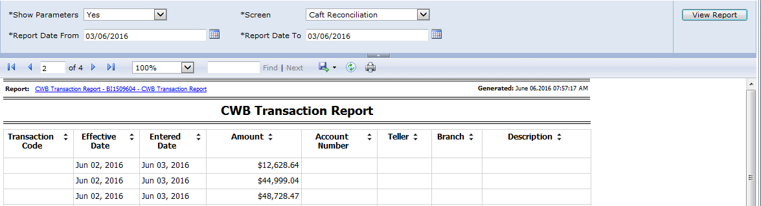
Typically, on Tuesday to Friday, the Effective Date is the previous business date.
On Monday, the Effective Date will be the previous Friday’s date.

Verification that the RBC Transaction Report has been downloaded:

- Click on Reports tab
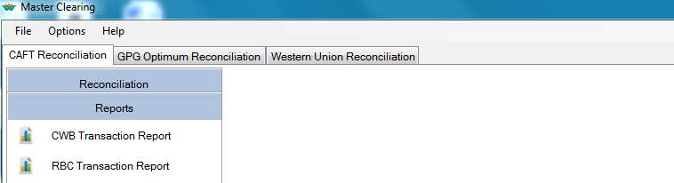
- Choose ‘RBC Transaction Report’ and ensure the dates, at the top (‘Report Date From’ & ‘Report Date To’) are one business day back
- On Mondays input date range from previous Friday to present day
- Ensure you see a number beside ‘Row Count’
- At the top right, click ‘View Report’
- Click on arrow to go to next page
- This report does not have any dates to verify. This step helps to verify the report has been downloaded.

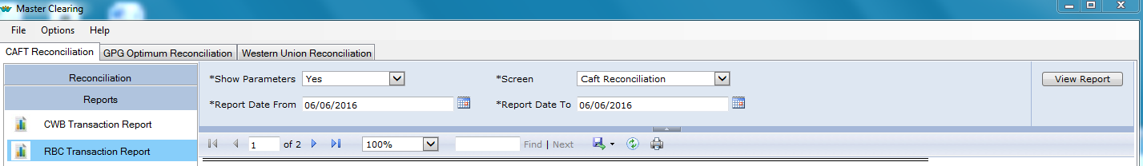
CAFT Reconciliation:
- Open the Master Balancing Program
- Click on ‘Reconciliation’
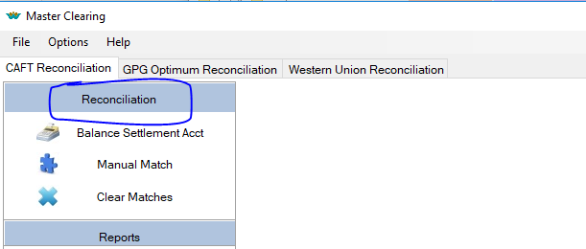

- Click on ‘ Balance Settlement Acct’

- Top left the ‘Reconciliation Date’ should be one business day back
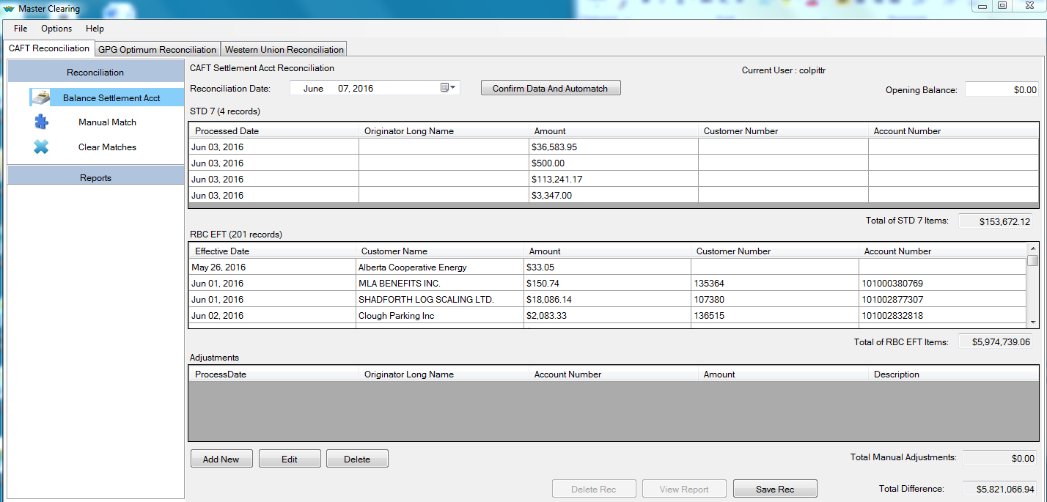
- There are 3 sections to this screen:
- STD 7- these are the Debits that have cleared the IA 17233
- RBC EFT - these are the Pre-Authorized credits that have credited the IA 17233
- Adjustments - this is where we enter items that are pending resolution
- At the top right, ‘Opening Balance’, enter the ‘Balance at Period End’ from the printout of IA 17233.
- In the ‘Adjustments’ section, click ‘Add New’ and enter the total of CAFT Chargebacks not posted. (You will get this total from looking at IA17233, and adding all the ‘CAFT Credit’ items that have a Booking Date of the current date, and a Value date of the last business date (the same as the Reconciliation Date). Click Save and go back to the Balance Settlement Acct.
- The ‘Total Difference’ box should be $0.00. If not, investigate. ** more info needed**
- Once the ‘Total Difference‘ box is at $0.00, click the ‘Save Rec’ button at the bottom right.
- Click ‘Confirm Data and Automatch’ box at the top centre.
- Click ‘Yes’ to confirm second Automatch, and ‘Yes’ again to confirm the ‘Group Match’
- The STD 7 section will indicate the number of items that are not matched
Manual Match
- To the left, click on ‘Manual Match’

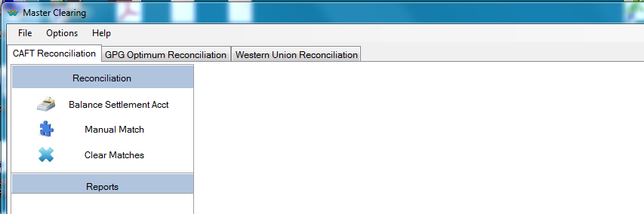

- Left side of screen = STD 7 records (Debits in IA 17233)
- Right side of screen = RBC EFT (Pre-Authorized credits in IA 17233)

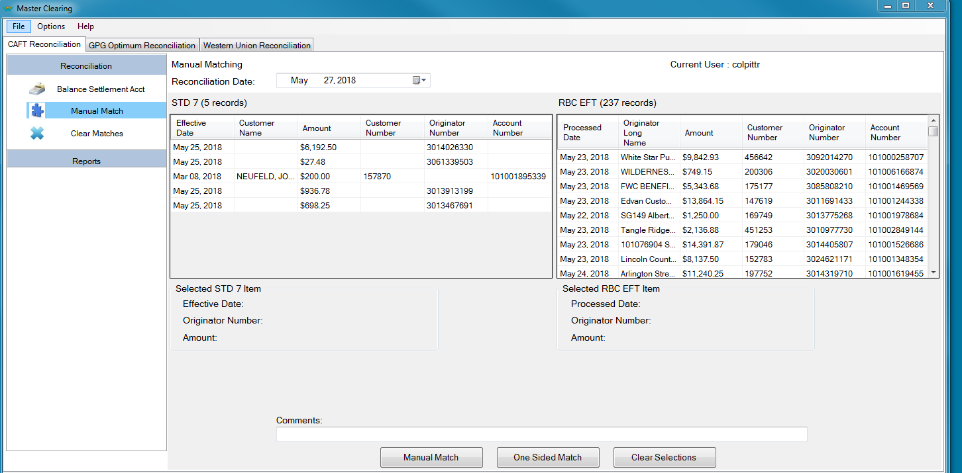

(Your ‘goal’ is to eliminate as many of the STD 7 records as possible.)

At the bottom of the Manual Match screen, there are 3 buttons:

  - Manual Match: To match two items together, the information (Amount & Originator Number) on both sides must be the same. (The name may not always match.) You probably won’t have any of these as the ‘Auto Match’ function should have already matched, and deleted these.

  - One Sided Match :
    - When items cannot be one-to-one manually matched together, use this button to match each side separately. For example, an originator has 2 RBC EFT’s which equals one STD 7 item, or visa versa, etc.
    - It is easiest to match by sorting each side in order of originator number. Do this by clicking on the Originator Number Heading on each side.
    - To match 2 to 1, 2 to 3, 1 to 2, etc. first make sure the total on each side balances. (Eg. Originator 3068546161 STD 7 Amount = $21,345.20, and RBC EFT Amounts = $21,000.00 and $345.20). If there are more items than needed on any side, look at the oldest dates on the RBC EFT (Credit) side first. These are usually the ones to be matched off first.
    - In the Comments field, type the originator name briefly, and the total you are matching. Copy and paste this comment, click on one of the matched amounts from the RBC EFT side, click back in the Comments field, paste, and click on One Sided Match. A window will pop up – are you sure you want to match one item alone? Click on Yes and confirm. Highlight the second RBC EFT item to be matched, paste comment again, and click on One Sided Match. Click Yes on the window pop up. Then click on amount from STD 7 side, paste comment, click on One Sided Match & Yes.
    - At the end of any matches, you can verify that the ‘Total Difference’ box on the ‘Balance Settlement Acct’ page is still at $0.00, by clicking on the Balance Settlement Acct tab. If it is not, look at the Clear Matches section ****more info. needed.
  - Clear Selections:
    - Remove any information that was typed in the Comment Box ???

- STD 7 items that do not match:
    - For each originator, look at Report 10 in CAFT for the date and amount. This amount may be only one or a few of the transactions from a larger file that has multiple due dates. The due dates can be verified by looking at the View History File Information in CAFT.
More info needed here

- Once all STD 7 items have been investigated, take a snippet of the ‘Balanced Settlement Acct’ screen of the Master Balancing program. Paste on a word document, add heading ‘CAFT RECONCILIATION – TODAY’S DATE and Reconciliation Date Print this page.
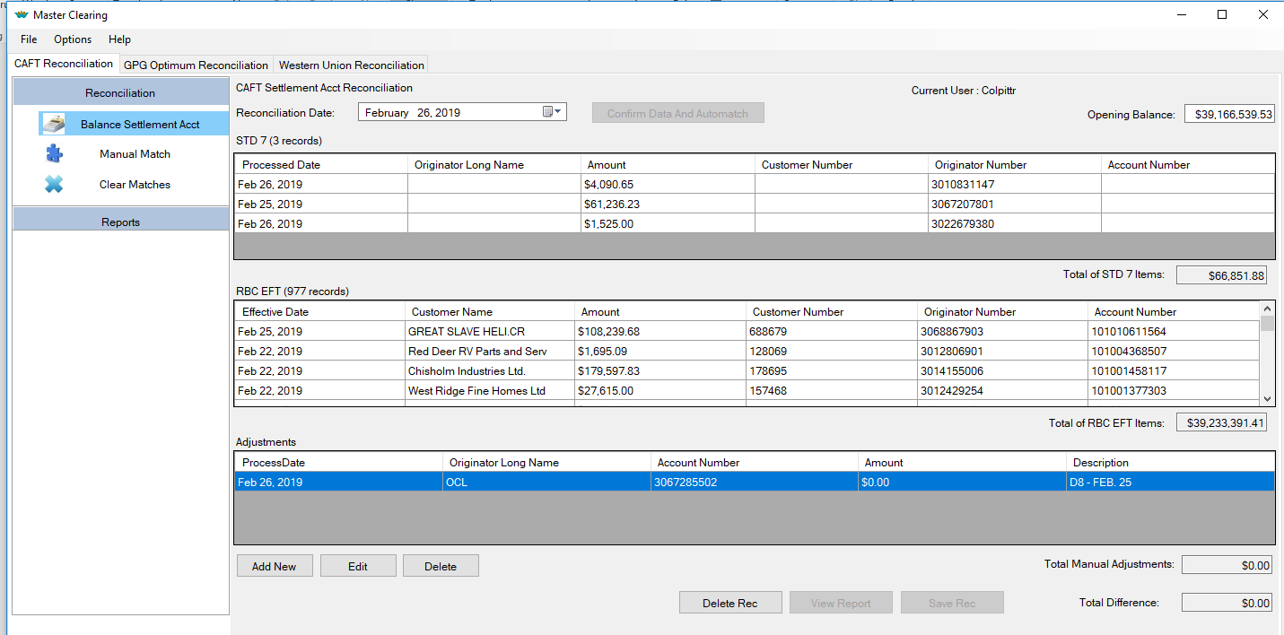

Creating CAFT Reconciliation Spreadsheet:
- In the Master Balancing program, choose ‘Reports’, then choose ‘Status Report’
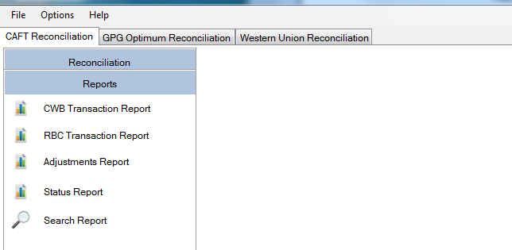
- In the ‘Report Date From’ enter the earliest RBC ‘credit’ transaction date and for the ‘Report Date to’ enter today’s date.
- In the ‘Match Status’ box, untick ‘Select All’ and only tick ‘Not matched’
- Click ‘View Report’ at the top right
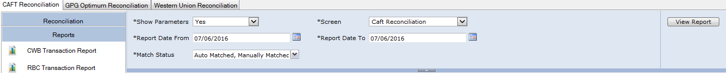
- Click the Download Icon dropdown and choose ‘CSV (comma delimited)’
- 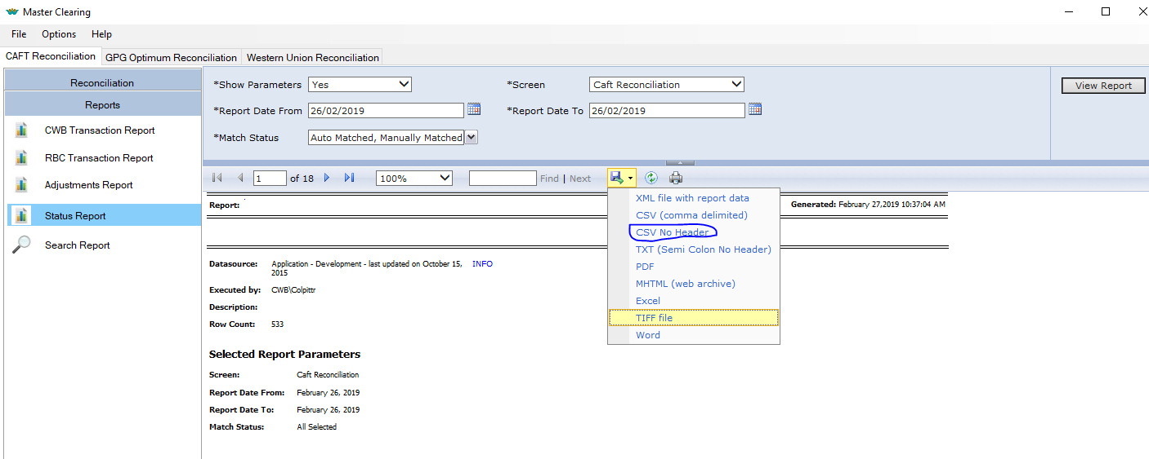
- Click on Open in the window that pops up & an excel worksheet with information will open
- Right click on the arrow cell above the 1 & left of the A. Click on copy.
- Open Master CAFT Reconciliation spreadsheet found in G/CASH MANAGEMENT SUPPORT/CAFT/IA 17233 Reconciliation and open the Master CAFT Rec worksheet
- Left click in the A1 cell and right click to paste the information
- Run the macro, Ctrl r (Hold down the Ctrl key and click on the r key)
- Look in the Amount Column for any items that are in brackets & red. These amounts & originator number(s) need to be cut and pasted (as a positive amount) at the top of the spreadsheet in the o/s D9’s section.
- Do an AutoSum on these transactions only. The total should match to the Total of STD 7 Items on the CAFT RECONCILIATION-Master Balancing snippet printout.
- Then you can delete the rest of the information from these lines where you cut the information from above
- Hi-light all the amounts in Column C and do an AutoSum at the bottom of this column
- This total should match to the Total of RBC EFT Items on the CAFT RECONCILIATION-Master Balancing snippet printout
- Delete columns F, G and H
- Change the new Column G to Accounting format
- In Column G, enter Balance for CAD17233 beside IA Balance, o\s D9’s total beside o/s D9’s and (as a negative) the final total of Column C beside the o\s RBC Credits.
- Enter any Adjustment amounts next. Typically these will be the total of the Credit File Chargebacks not posted, and should be entered as a negative.
- Balance should be zero
- To Save, click on File, Save As and rename as Mmm.date Master CAFT Rec and Save in the appropriate Year and Month folder. Eg. Mar. 4 Master CAFT Rec in G>CASH MANAGEMENT SUPPORT>CAFT>IA 17233 Reconciliation>2019>MARCH
- Please do not save in Master Spread Sheet. Do a ‘Save As’
- Print the entire report.
- Close out of all applications
- Attach the word document screen shot of CAFT RECONCILIATION-Master Balancing
- Attach T-24 printout of IA 17333
- Attach T-24 printout of IA 10286
- Initial all totals
- This must be audited by another CMS member

